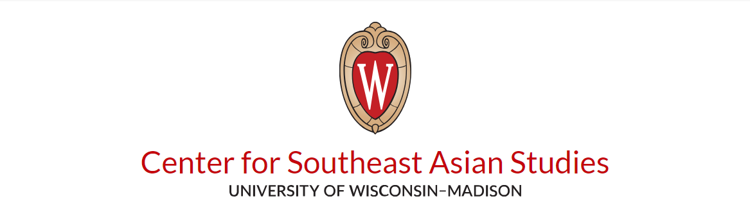

Spring 2027
Southeast Asian Studies Core Courses

UNDERGRADUATE

Anthropology
ANTHRO 490 (LEC, 3cr)
Archeology of Ritual and Religion
F 9:00am-11:30am
5105 Sewell Social Sciences
Nam Kim

Asian American Studies
ASIAN AM 101 (LEC, 3cr)
Introduction to Asian American Studies
MW 2:30-3:45PM
1101 Mosse Humanities Building
Victor Jew

ASIAN AM 170 (LEC, 3cr)
Hmong American Experiences in the United States
TR 1:00-2:15PM
2212 Levy Hall
Mai See Thao

ASIAN AM 540 (LEC, 3cr)
Hmong American Studies
TR 4:00-5:15PM
L1196 Levy Hall
Instructor: TBD

Asian Languages and Cultures
ASIAN 100 (LEC/DIS, 3cr)
Asian Punk: Music, Resistance
MW 3:30-4:20PM
168 Noland Hall
Anthony Cerulli

ASIAN 236 (LEC/DIS, 3cr)
Asia Enchanted: Ghosts, Gods, and Monsters
MW 12:05-12:55PM
1240 Computer Sciences
Jamal Jones

ASIAN 379 (LEC, 3cr)
Cities of Asia
MW 2:30-3:45PM
L150 Conrad A. Elvehjem
Preeti Chopra

ASIAN 388 (LEC, 3cr)
Food in Asia, Asia in Food
TR 9:30-10:45AM
114 Van Hise Hall
Heangjin Park

Communication Arts
COM ARTS 362 (LEC, 3cr)
The Discourse of Dictators, Demagogues, and Extremists
TR 2:30-3:45PM
4281 Helen C. White Hall
Mary McCoy

Educational Policy Studies
ED POL 240 (LEC/DIS, 3cr)
Comparative Education
MW 11:00-11:50AM
MW 12:05pm-12:55pm
B1A Lowell Center
Jennifer Otting
ED POL 260 (LEC, 3cr)

Introduction to International
Education
MW 2:30-3:45AM
495 Van Hise Hall
Jennifer Otting

Environmental Studies
ENVIR ST 270
The Environment: Religion
and Ethics
ONLINE
Anna Gade

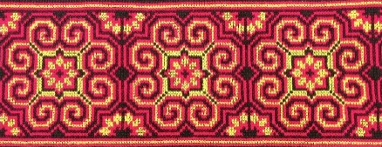

UNDERGRADUATE AND GRADUTATE

Anthropology
ANTHRO 322
The Origins of Civilization
TR 9:30am-10:45am
6203 Sewell Social Sciences
Nam Kim

Asian Languages and
Cultures

ASIAN 403 (LEC, 3cr)
Southeast Asian Literature
MW 2:30-3:45PM
5106 Sewell Social Sciences
Tyrell Haberkorn

ASIAN 650 (SEM, 3cr)
Communism, Anarchism, and Other Asian Lefts
M 4:30-7:00PM
209 Van Hise
Tyrell Haberkorn

Geography
GEOG 340
World Regions in Global Context
ONLINE
Kristopher Olds
GEOG 336 (LEC 3cr)

International Environmental Governance
TR 4:00-5:15PM
1257 Computer Sciences
Ian Baird

GEOG 358 (LEC 3cr)
Human Geography of Southeast Asia
TR 11:00AM-12:15PM
4281 Helen C. White
Ian Baird

History
HIST 375 (LEC DIS, 3cr)
The Cold War
TR 2:30-3:45PM
L1210 Levy Hall
Alfred McCoy

HIST 600/755 (SEM,3cr)
Empires and Revolutions in Southeast Asia
T 11:00am-12:55PM
5240 Levy Hall
Alfred McCoy

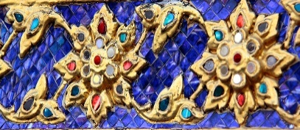

LANGUAGES

Hmong/Hmoob

ASIALANG 126 (4cr)
Second Semester Hmong
MTWR 8:50-9:40 AM
399 Van Hise
Choua Lee
ASIALANG 226 (4cr)
Fourth Semester Hmong
MTWR 9:55-10:45 AM
495 Van Hise
Choua Lee
ASIALANG 326 (4cr)
Sixth Semester Hmong
TR 1:00-2:15 PM
475 Van Hise
Choua Lee

Indonesian

ASIALANG 128 (4cr)
ASIALANG 228 (4cr)
ASIALANG 332/442 (4/3cr)
Second Semester Indonesian
MTWR 12:05-12:55 PM
ONLINE
Erlin Barnard

Fourth Semester Indonesian
MTWR 9:55-10:45 AM
ONLINE
Erlin Barnard

Sixth Semester Indonesian
TR 1:00-2:15PM
ONLINE
Erlin Barnard

Thai

ASIALANG 130 (4cr)
Second Semester Thai
MTWR 8:50-9:40 AM
294 Van Hise Hall
Janpanit Surasin
ASIALANG 230 (4cr)
Fourth Semester Thai
MTWR 9:55-10:45 AM
294 Van Hise Hall
Janpanit Surasin
ASIALANG 330 (4cr)
Sixth Semester Thai
MTWR 11:00 AM-12:15 PM
294 Van Hise Hall
Janpanit Surasin

Vietnamese

ASIALANG 132 (4cr)
Second Semester Vietnamese
MTWR 3:30-4:20PM
478 Van Hise Hall
Hong Dinh
ASIALANG 232 (4cr)
Fourth Semester Vietnamese
MTWR 2:25-3:15PM
290 Van Hise Hall
Hong Dinh
ASIALANG 332 (4cr)
Sixth Semester Vietnamese
MTWR 1:00-2:15PM
290 Van Hise Hall
Hong Dinh

